Creative Spark
Higher Education Enterprise Programme

Createathon Facilitator Manual

Introduction
The following document provides guidance for you, as a facilitator, to design and deliver Day 1 of the Createathon. This has been adapted from documents available to you to download and adapt yourselves via our project website:
You should have already read the ‘Preparing for a Createathon’ guide.
We will go on in the next sections to describe the facilitator tasks and team activities so that you know the rationale behind our thinking.
As this is part of your own active learning experience as part of the Educator Professional Development Workshop 2022, this document also provides you with an overview of the activities we have included to enhance your own development.
In the Createathon, you are required to participate as Facilitators and we can decide which sessions you would like to participate in during the first morning.

Monday 13th June
Students and Creative Enterprises | Educators  (All in Main Room) | Time  Location | Resources
 | Introduction and Welcome to Educator Development Programme June 2022 | 10:00  Main Room | Facilitator Handbooks  Pens
 | Development Partner Planning | 10.20  Main Room | Schedule – facilitator slots
Students & Businesses Arrive | Tea break | 10.45
Lead Facilitator Task: Introduction and Welcome |  | 11.00  Main Room | Slides – AV  Programme Handbooks
Activity 1: Creativity Warm Up |  | 11.15  Main Room | Circles activity sheets  Pens
Facilitator Task: Debrief Creativity Warm Up and introduce the next activities |  | 11.35  Main Room | Slides - AV
Creative enterprises work with student teams  > Activity 2: Enterprise Storytelling (45 minutes)  > Activity 3: Personal Values Exercise (15 minutes)  > Activity 4: Creating a Problem Statement (15 minutes) | Developmental observations | 11.45  Breakout Rooms | Flip chart paper  Flip chart pens  Programme Handbooks
Lunch |  | 13.00
Facilitator Task: Introduction to Creative Business Model Canvas (CBMC) |  | 14.15  Main Room | Slides - AV
Creative enterprises work with student teams in Breakout Rooms  - Activity 5: Developing the Creative Business Model Canvas | Developmental observations | 14.25  Breakout Rooms | CBMCs  Pens  Post-its
Tea break |  | 15.30
Facilitator Task: Check progress and introduce next exercise |  | 15:45  Main Room
Creative enterprises work with student teams in Breakout Rooms  - Activity 6: ‘What would success look like?’ exercise | Using & developing resources & toolkits | 16:00  Breakout Rooms | Programme Handbooks
Wrap Up and Next Steps |  | 16.45  Main Room

Day 1: Workshop Schedule

Day 1 Sessions
The workshop largely comprises practical activities, in which the teams are given specific tools to apply to tasks and the time to go into breakout spaces and work as a team. The student teams will be working directly with their creative enterprise. Your role as facilitator is to ensure energy levels remain high, that the teams are confident in taking on the activities, that you keep to time, and that this is a fun and valuable experience for all participants. There are six activities on Day 1 (listed below) – this is a high-paced workshop – and your role is crucial. We go on to describe each activity in turn, interspersed with guidance for your facilitator tasks.

- Creativity Warm-Up
- Enterprise Storytelling
- Personal Values Exercise
- Creating a Problem Statement
- Developing the Creative Business Model Canvas
- What would success look like?

Introduction and welcome (10 mins)
This is your chance to set the scene and bring your energy and enthusiasm into the workshop. You’ll need to welcome everyone, but time is short so we don’t recommend you asking everyone to introduce themselves – you only have 10 minutes!

You should show the schedule for the first day and set/re-enforce your ground rules for the workshop. If you are in a physical location you’ll need to let everyone know the the ‘housekeeping’ rules (emergency evacuation procedures, facilities etc.).

Activity 1: Creativity Warm-Up (30 mins)

Purpose:
It is important for you as facilitators to build rapport with the participants, especially as you may have not met before. It is also necessary for the student teams to develop a working relationship with their creative enterprise. We suggest this is done by playing some creativity games to help students relax, get to know the creative enterprise owner, and also demonstrate how creative they are by practising generating ideas, ahead of working on their creative enterprise challenges.

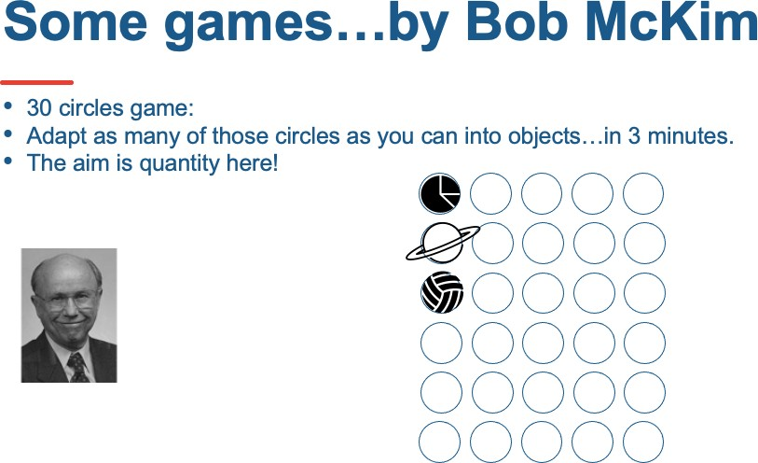

This is also an opportunity to introduce some of the theory around ‘the how to’ of ideation and also to give a context to innovation – incorporating a wide scope of ideas to improve products, processes and develop ideas for new services.

Once the teams are warmed up you are going to get them working together in their breakout spaces. It is important that you brief the teams on Activities 2, 3 and 4 before they leave the main room. It is a lot for them to take in so you need to give them chance to clarify expectations and ask any questions. You will also need to ensure that you drop into their breakout spaces to check on their progress. In a physical venue you may need to be active!

1The PowerPoint deck is available on the Creative Spark website https://research.ncl.ac.uk/creativespark/createathontoolkit/day2_createathon/

Activity 2: Enterprise Storytelling (45 mins)

Purpose:
This is an opportunity for the students to hear the story of their creative entrepreneur and their enterprise. While this could be in the form of a narrative from the entrepreneur, we recommend this in the form of a conversation led by the students. This way they gain insights into the motivation of the entrepreneur and a snapshot as to where the enterprise is presently, in relation to the challenge that they have

scoped out ahead of the Createathon in the form of the Business Brief (available for download on our Creative Spark website2).

Format:
As a facilitator, you will be instructing students to ask questions to their entrepreneur to get the “story” of the business. Basic questions from students can be formulated under the key headings:
- Origin of the business and people involved in this business.
- Background of the founder of the creative enterprise.
- Significant incidents in the enterprise’s history.
- Product and/or services in the creative enterprise’s current portfolio.
- Current customer and revenue streams.
- The origin of the challenge set for the Createathon.

1To know more about the 30 circles game: https://www.ideo.com/blog/build-your-creative-confidence-thirty-circles- exercise
2Creative Spark website: https://research.ncl.ac.uk/creativespark/createathontoolkit/day1_createathon/

Activity 3: Personal Values Exercise (15 mins)

Purpose:
In this exercise the student teams are going to capture and organise their client’s personal values. What makes the business owner feel passionately committed to what they are doing in their business?

Format:
Students should ask them to consider what is:
- Always important
- Sometimes important
- Rarely important
- Never important

The teams should record notes to synthesise their findings from your conversations with their entrepreneur.

This activity originates from the NESTA: Creative Enterprise Toolkit2. When working with owners of creative enterprises (indeed when working with any entrepreneur) it is important to recognise that their venture is a product of their passion and personal values. With creative enterprises the venture will also reflect the owner(s)’s own creative practice(s). It is vital for you to understand the personal values of the owner that underpin the enterprise so that you do not suggest any business direction or action that would go against those values.

NESTA provides a list of values that you could use as prompts for this task: Accountability, Achievement, Advancement, Aesthetics, Authority, Balance, Belonging, Celebrity, Challenge, Co-operation, Community, Creativity, Credibility,

Curiosity, Determination, Discipline, Dynamism, Effectiveness, Excellence, Excitement, Fame, Financial gain, Financial security, Freedom, Grace, Growth, Harmony, Helping others, Helping society, Honesty, Humour, Independence, Influencing others, Innovation, Integrity, Intellectual status, Joy, Justice, Knowledge Leadership, Loyalty, Meaningful work, Monetary gain, Openness, Originality, Peace, Power, Public service, Quality, Recognition, Reputation, Resilience, Respect, Responsibility, Self-respect, Spontaneity, Stability, Status, Sustainability, Teamwork, Time freedom, Tolerance, Tranquillity, Trust, Variety, Vision, Wisdom, Work/Life balance, Working alone
Source: Adapted from www.media.nesta.org.uk

1Miro Board Values Exercise template: https://miro.com/app/board/o9J_lFjrMhY=/ 2NESTA: Creative Enterprise Toolkit: https://media.nesta.org.uk/documents/creative_enterprise_toolkit_english_online.pdf

Activity 4: Creating a Problem Statement (15 minutes)

Purpose:
In this context, a Problem Statement is a way of describing the gap between where the creative enterprise is at present and where they want to be after the Createathon.

The creative enterprise has established where they want to be through their challenge brief and through the storytelling exercise the teams have established where the creative enterprise is at present. Creating a Problem Statement aids analysis of the creative enterprise challenge and will help the team consolidate all assumptions and act as a touch point to test any potential solutions for the ongoing process of designing a solution for the company challenge. It is important to remember however that solutions are not proposed at this stage.

The benefits of a Problem Statement at the very beginning of the Createathon are:
- Touchpoint throughout the workshop process
- Communication tool for team to consolidate information from initial discussions with creative enterprise/entrepreneur
- Feedback prompt for plenary session
- Each team can share the Problem Statement with facilitators and participants.

Format:
Students should describe what is the challenge faced by the enterprise at this stage and where the enterprise wants to be by the end of the Createathon.
- The challenge of (describe the challenge) .
- Affects (who is affected by the problem) .
- The impact of which is (what is the impact of the challenge) .
- A successful solution would (list some key benefits of a successful solution, ensuring that you have considered the personal values of your creative enterprise) .

This will have been a very intensive session for the teams so they deserve a break at this stage. Check that they all feel on track and then let them go and grab a drink, stretch their legs, but set them a time to be back in the room to be briefed on the next task.

Facilitator Task: Introduction to the Creative Business Model Canvas (CBMC) (15 mins)

Purpose:
The Business Model Canvas presents a visual overview of the 9 components of a business on one page and is:
- A strategic management and lean start-up template for developing new OR documenting existing business models.
- A visual chart with elements describing a firm’s value proposition, infrastructure, customers and finances.
- A tool to assist in testing and aligning business activities.

Format:
The 9 boxes of the canvas let students visualise all the components needed to turn customer needs/problems into a sustainable business model. There is a very helpful short video https://www.youtube.com/watch?v=QoAOzMTLP5s that you could show to students during this session. You could also prepare a slide detailing the 9 boxes to show here. Let students read through these and familiarise themselves with the meaning of each box. Be prepared to answer questions and maybe show an example of a completed BMC for a well-known company. This video should help students understand their task quickly: https://www.youtube.com/watch?v=wlKP-BaC0jA (Links to an external site).

- Value Proposition - what does your business offer and what benefits do your products/services offer customers?
- Customer Segments - who will use/purchase your products or services?
- Distribution Channels - how will you reach your customers and offer them your value proposition?
- Customer Relationships - how will you acquire and retain customers?
- Revenue Streams – what revenue streams are generated by your value proposition(s)?
- Key Activities – what tasks do you need to carry out in order to fulfil your business purpose?
- Key Resources - what are the main inputs you need to create your value proposition, service your customer segment and deliver the product to your customer?
- Key Partners – who are the partners you need to enable you to perform your key activities?
- Cost Structure – what are the costs of delivering your value proposition?

The (Creative) Business Model Canvas in this workshop is used as a tool to capture and develop the team’s design-led thinking and to iterate to build the final solution to be presented within the final presentation in Day Two. You, as a facilitator, should emphasise that because these are established creative enterprises much of the CBMC can be completed from the enterprise storytelling. The focus should be on the areas of the CBMC that have been highlighted in the problem statement.

We provide a Business Model Canvas template, however, we have also created the Creative Enterprise Canvas for businesses specifically from the creative

sector. Both contain numbered sections and questions to guide students in filling in the BMC.
Business Model Canvas
(3) Channels
How does your value proposition reach your customer?
Where can your customer buy or use your products or services?
(6) Key resources
What are the resources you need to create & deliver your value proposition?
(1) Customer groups
For whom are you creating value?
What are the customer segments that either pay, receive or decide on your value proposition?
(8) Key partners Who are your most important partners?
Which key resources do you acquire from partners?
Which key activities do your partners perform?
(7) Key activities
What are the activities you perform every day to create & deliver your value proposition?
(2) Value Proposition What is the value you delivery to your customer?
Which of your customer's problems are you helping to solve?
What is the customer need that your value proposition addresses?
What is your promise to your customers?
What are the products and services you create for your customers?
(4) Customer relationships What relationship does each customer segment expect you to establish and maintain?
(9) Funds Out (Cost Structure)
What are the important costs you make
to create & delivery your value proposition?
(5) Funds In (Revenue Streams)
How do customers reward you for the value you provide to them? What are the different revenue models?

Source: Adapted from Strategyzer.com

The Creative Enterprise Canvas
(8) Key partners
Who do we need to collaborate with/partner with?

What do we need to share?

Who can help us deliver the business or project?
(7) Key activities
What do we need to do to deliver the value to our audiences/customers?
(2) Value Creation
What unique experiences, services or products are we offering to our audiences/customers?

Which of our audiences/customers problems are we trying to solve?

What are we helping audiences/customers to achieve?

What audiences/customers needs and interests are we helping to satisfy?

What are we creating which is valuable to our customers/audiences?
(4) Audience/Customer relationships
What type of relationship do we need with our audiences and customers?
How can we connect, develop and maintain relationships with audiences/customers?
(9) Funds Out (Cost Structure) What are the costs? Resources?
Activities?
(5) Funds In (Revenue Streams)
What is the most significant source of funds for our project/business? What are our audiences/customers willing/able to pay for?
(3) Channels
How do we reach each of our different audiences/customer groups?
How do we communicate our offer?
How do we deliver our creative product
(6) Key resources
What resources do you need to make our idea work?
Intellectual/creative? People?
Physical? Financial? Technical?
(1) Customer groups
Who are our most important audiences/customers?

Who will be interested in our experiences, services or products?

How can we understand groups of customers and identify their needs/interests?

Source: Adapted from Strategyzer.com

Activity 5: Developing a (Creative) Business Model Canvas (60 mins)

Purpose:
The CBMC should be completed focusing on the sections relevant to the enterprise’s priorities.

Note: If the creative enterprise seems to be struggling to define the benefits they offer to their customers/clients then it could be useful to use the Value Proposition Canvas first (see below). Here we link to a very brief overview of the Value Proposition Canvas on YouTube - https://www.youtube.com/watch?v=aN36EcTE54Q .

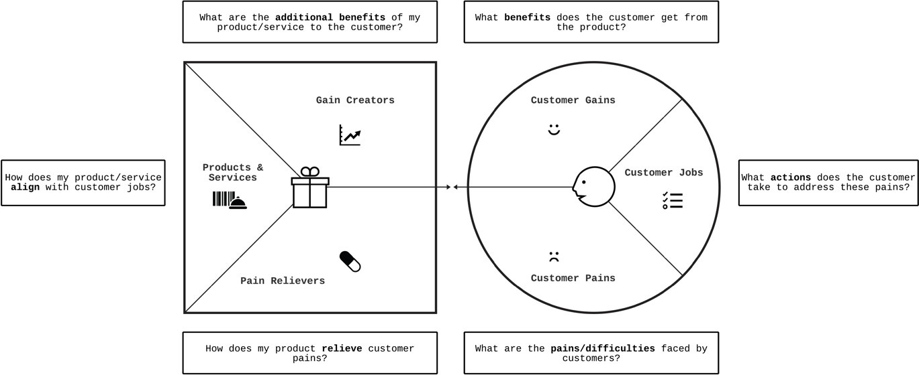
Source: Adapted from Strategyzer.com

Action 6: What would success look like? (30 mins)
Success in business means something different to each individual entrepreneur and getting the students to explore this topic with their business owner is essential so they can glean further insights into the specific Createathon business challenge and what it would mean if the challenge was successfully addressed. It is part of the information gathering stage, so the students can frame the recommendations that they are going to be working on to fit the entrepreneur’s vision of developing their enterprise.

Key areas for the students to discuss with their entrepreneur are:
  - What are their ambitions for their business/this project? (encourage them to think as big as possible)
  - What impact could it have on their customers, on society, on the environment?
  - What impact could successfully achieving the challenge have on their own life and work?

The fun part of this is that you are asking the student teams to represent this visually.

  - Could someone who was addressing childhood literacy demonstrate they had helped one million kids to read?

  - Could a fashion designer be featured on the front cover of a top fashion magazine?
  - Could a film maker win an Oscar for their work?
  - Could they make a 1 million or 100 million £/€/$ from their product or service?
  - Could they employ 100 people?

Success should align with the entrepreneur’s personal values that the students elicited earlier in the day.

Wrap up and Next Steps (15 mins)

Purpose:
It is really important for the students and the businesses to know the next steps for the Createathon. Between workshops the students are going to start to prepare a Pecha Kucha presentation that will present back what they have learned about the business, what success would look like, and outline their proposed solutions. Then on Day Two they are going to spend time finalising their Pecha Kucha and an Action Card on Miro, before the businesses join the session.

A Pecha Kucha is a 20x20 presentation format with 20 slides (mainly using images), each shown for 20 seconds. Since not all students are familiar with this presentation style, we’ve prepared some resources for them to start them off and provided an Animated PowerPoint slide deck. (Available for download on the Creative Spark website1.)

Key homework action for students:
They should start to prepare their team’s Pecha Kucha presentation. Students can use these video resources and more are available online.

- Leanne Robinson-Maine - Top Tips for Pecha Kucha Presenters Do you want to know more? https://www.youtube.com/watch?v=5df7XtyvDb4 (Links to an external site.)
- Brian Scott Peterson, Pecha Kucha's Global Dude at PKHQ in Tokyo, has watched literally 1000's of Pecha Kucha Presentations. He has given quite a few as well and thinks he knows, from lots of experience and a birds-eye view from headquarters what makes a truly great Pecha Kucha Presentation. Do you want to know more? http://www.youtube.com/watch?v=JlcDz4kLck8 (Links to an external site.)

Pecha Kucha about Pecha Kucha, by Hans Van de Water
A world without boring PowerPoint presentations? It is possible! In this video public speaking mentor, Hans Van de Water (The Floor is Yours) explains to you what Pecha Kucha is about and how it works. Do you want to know more? https://www.youtube.com/watch?v=gZJc8PB2DsQ (Links to an external site.)

Students should not be using any images that are subject to copyright. We signpost students to Unsplash2, as all images published can be used for free.

What should students know?

  - Inform students of what support is available from facilitators before day 2 of createathon: e.g. you could announce a schedule of drop-in slots online
  - Ensure students have clarified how/how often the students can access their creative enterprise before day two of the Createathon.

Then close the session by thanking all participants and making sure they know where to be for Day Two!

Day 2: Workshop Schedule

The following document provides guidance for you, as a facilitator, to the design and delivery of Day 2 of the Createathon. You should have already read the ‘Preparing for a Createathon’ guide and the ‘Createathon Day One’ Guide.

It is important to note that the creative enterprises do not join until mid-way through Day Two.

We will go on in the next sections to describe the facilitator tasks and team activities so that you know the rationale behind our thinking.
Introduction and welcome - Student teams only (15 mins)
This is your chance to ask how the student teams have been progressing since Day One. This will help you identify which teams are thriving and which ones may need more assistance. You can give them the schedule and highlight that they have less than 2 hours to finalise their Pecha Kucha and complete an Action Card with recommendations for their business owner.

Allow time for questions and keep answers focused on the events logistics and maintaining the spirit of collaboration.

Activity 1 - Finalise Pecha Kucha presentations and Action Card recommendations (1 hour and 45 mins)

Purpose:
This is an opportunity for student teams to work independently, without help from entrepreneurs.

They will finalise their PechaKucha (see ‘Createathon Day One’ guide) that will present back:
- what they have learned about the business
- what success would look like for their enterprise and
- outline their proposed solutions for the Createathon challenge
They will also complete an Action Card1 where their recommendations and proposed solutions can be outlined in more detail.

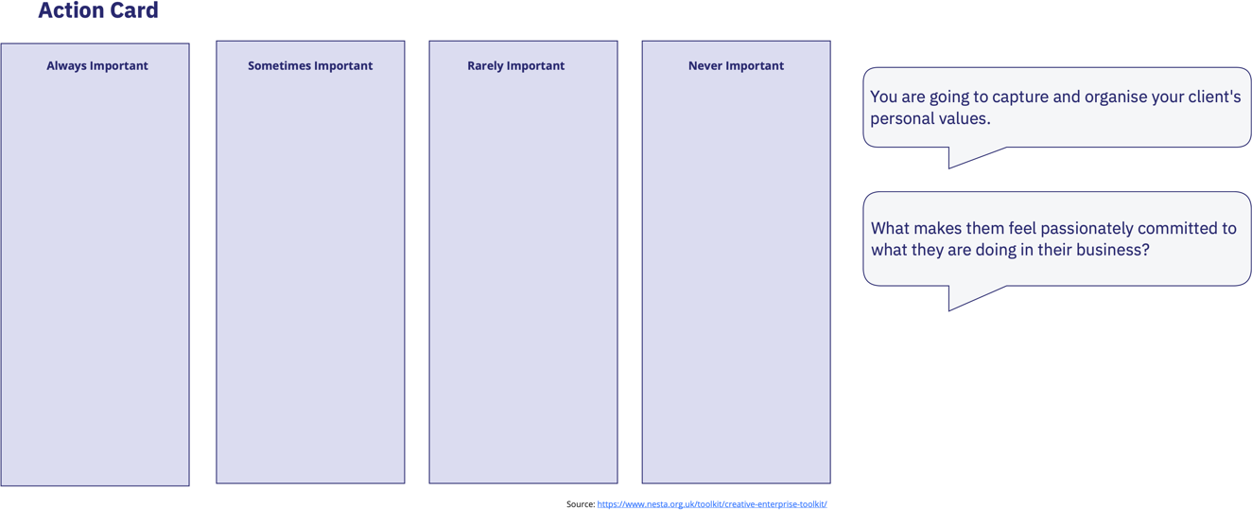

Activity 2 - Discussion of future and action card recommendations
After a welcome session in the main room (physical or virtual) the creative enterprises will join the student teams in their breakout rooms. Students will rehearse their Pecha Kucha presentations and sense check for clarity and appropriateness of recommendations being proposed. This also gives the chance for the entrepreneur to ask and questions and give their initial feedback. It is important at this stage for the students to check with their creative entrepreneur that they have their permission to share the presentation with all the participants of the Createathon – this gives the entrepreneur the chance to ensure that there is nothing in Pecha Kucha or recommendations that is confidential or that the entrepreneur does not want them to share with the wider event audience.

Any final amendments to the Pecha Kucha can be made collaboratively.

1Action Card on Miro: https://miro.com/app/board/o9J_lFjrMhY=/

Activity 3 - Presentation of the Pecha Kuchas

Format:
Each team delivers their presentation on the template we have provided. That template enforces the 20x20 format, so each presentation should last for 6 minutes and 40 seconds exactly! Agree a running order for the student teams (consider allowing nervous students to go first so they can get the task done and be able to then relax and fully engage with the other students’ presentations).

Again, you need to keep to a tight schedule to keep everyone engaged, so allow a couple of questions from the audience, before giving the chance for the entrepreneur to give their feedback. Again, choosing the order carefully can work well – we usually find that the entrepreneurs are generous in their praise and feedback, but there can be exceptions.

Notes on presenting
In a physical environment you will have to assess how the Pecha Kucha presentations can be shared most effectively in line with any IT security issues/hardware availability. We suggest uploading them to some form of shared cloud drive that the facilitators set up so that confidentiality can be respected.

Takeaways
The businesses should be provided with a copy of their Pecha Kucha and Miro Board. The students could also be allowed to save their Pecha Kucha and download their Miro Board as a record of achievement. These outputs can be used as evidence of the student’s entrepreneurial learning outcomes, demonstrating they have learnt new skills such as working in an interdisciplinary team, are practiced in customer-led design approaches, have gained creative problem-solving skills and have the ability to work under pressure within tight timescales. Please make sure the businesses are fine with the information shared in these pieces of student work.

Wrap up the event and thanks (15 mins)
Facilitators summarise key learning points from Day Two and answer any final questions from students and enterprises. The session is closed with expressions of thanks and appreciation for everyone’s hard work and participation.

A Certificate of Attendance and Completion will be presented to students in exchange for completion of an event evaluation form.

A sample certificate is available for download from our Creative Spark website1.

1Creative Spark website: https://research.ncl.ac.uk/creativespark/createathontoolk

Footnotes

1Creative Spark website: https://research.ncl.ac.uk/creativespark/createathontoolkit/day1_createathon/
2 To access Unsplash: https://unsplash.com/

